WEEK 7: REACT

OUTPUT

9. Create a React Application named “cricketapp”
Flag=true
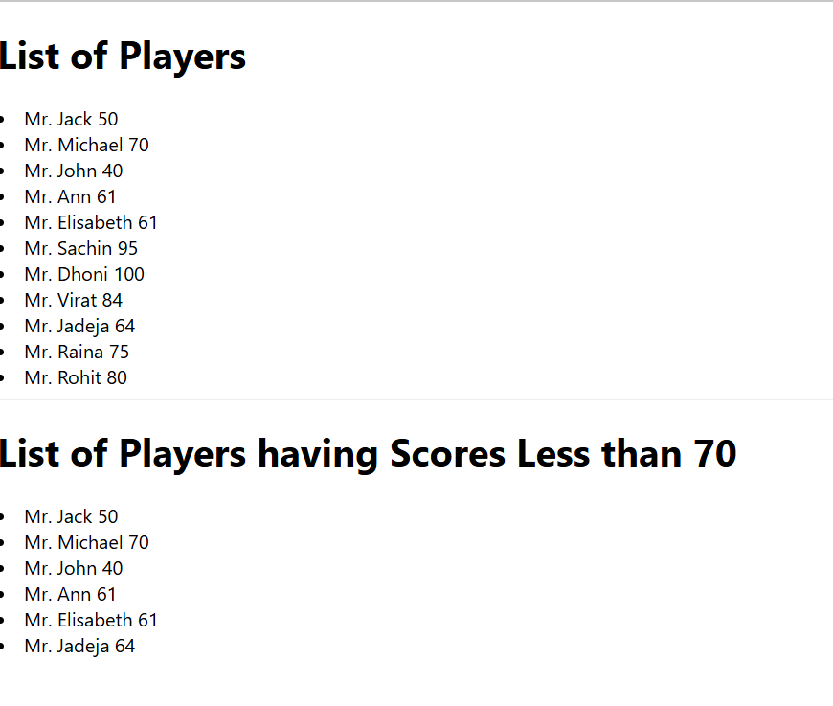

Flag=false
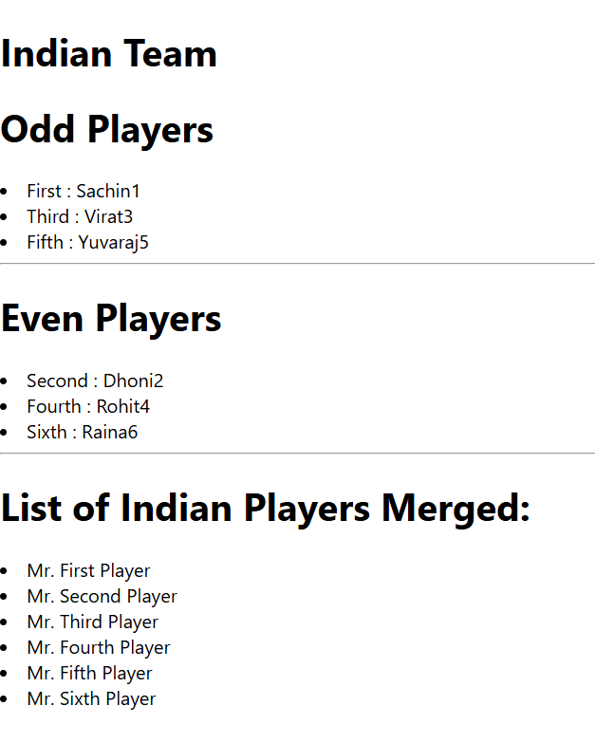

10. Create a React Application named “officespacerentalapp” which uses React JSX to create elements, attributes and renders DOM to display the page.

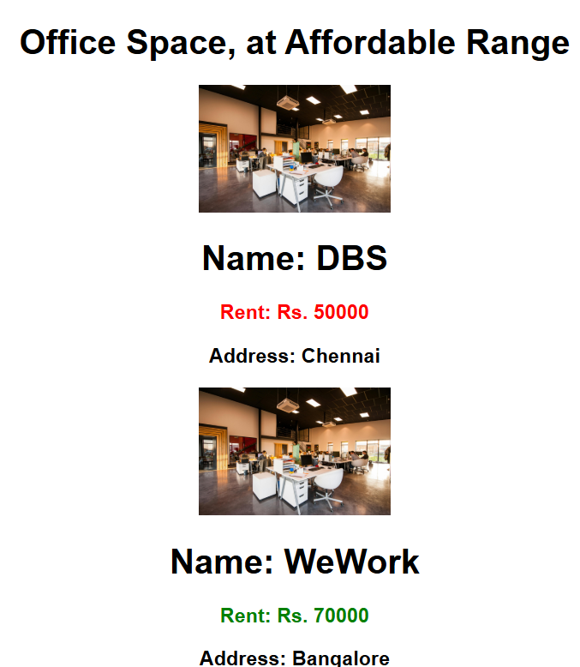
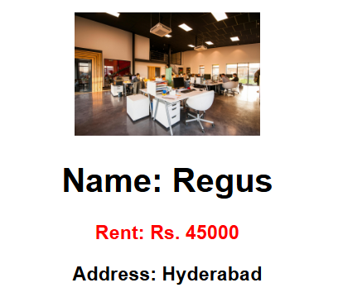

11. Create a React Application “eventexamplesapp” to handle various events of the form elements in HTML.

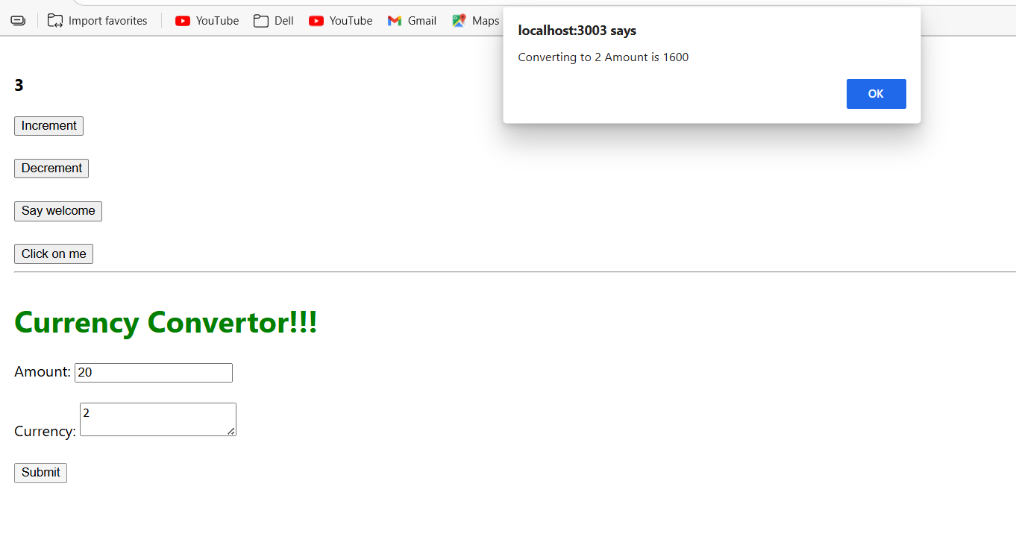
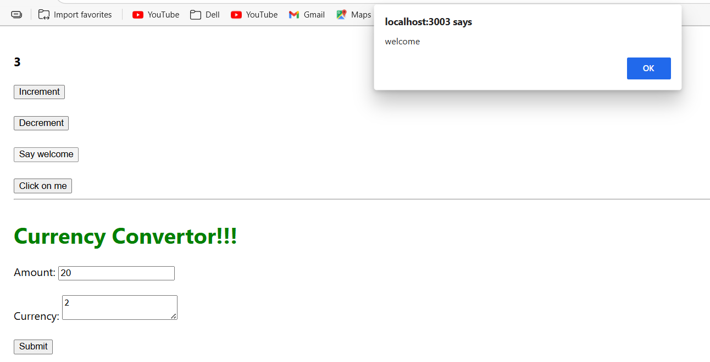

12. Create a React Application named “ticketbookingapp” where the guest user can browse the page where the flight details are displayed whereas the logged in user only can book tickets.

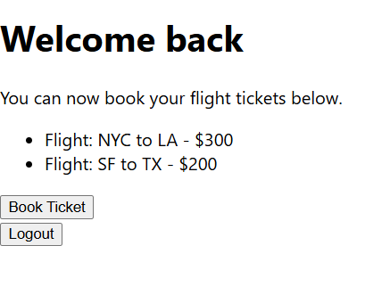

13. Create a React App named “bloggerapp” in with 3 components.

- Book Details
- Blog Details
- Course Details

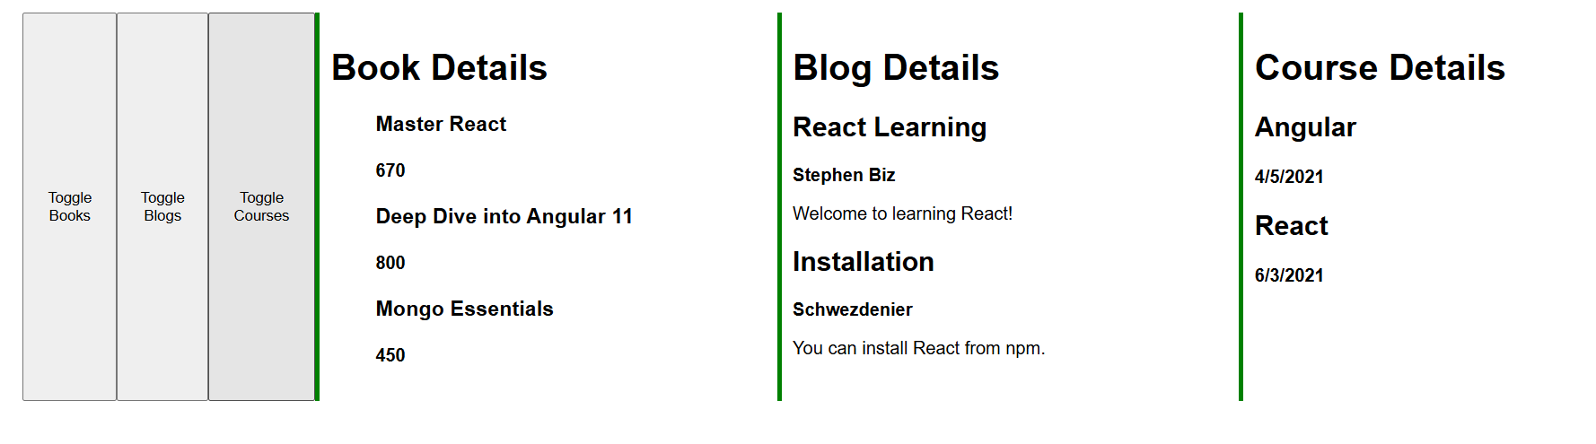

Additional exercises

15. Create a React App named “ticketraisingapp” which will help to raise a complaint and get it resolved.

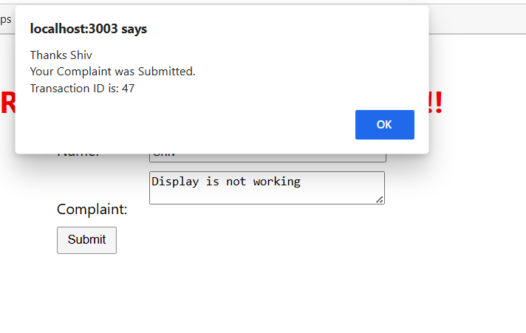
16. Create a React App named “mailregisterapp” which will have a component named “register.js”. Create a form which accepts the name, email and password and validate the fields as per the following:

- Name should have atleast 5 characters
- Email should have @ and .
- Password should have atleast 8 characters.

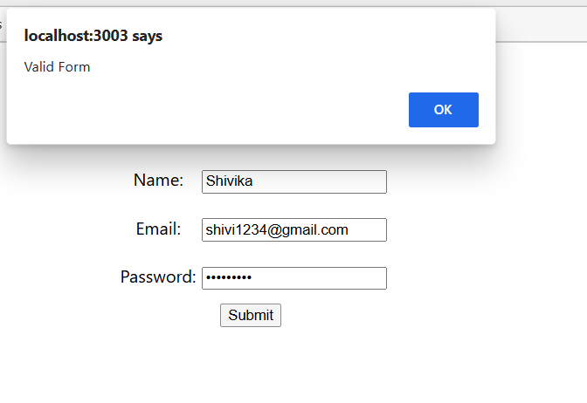
17. Create a React Application “fetchuserapp” which will retrieve the user details from https://api.randomuser.me/ and display the title, firstname and image of a user.
Create a component named “Getuser” and in the asynchronous method “ComponentDidMount ()” invoke the URL using fetch method and the response can be displayed in the render method of the component.

